

**FUNDUS IMAGE ANALYSIS FOR DETECTION OF GLAUCOMA USING DENSELY CONNECTED NEURAL NETWORKS**

**MINI PROJECT REPORT**

***Submitted by***

**KEERTHIVASAN R (412418104035)**

**MANIKANDAN A (412418104101)**

**THIRUKUMARAN C (412418104109)**

***in partial fulfillment for the award of the degree of***

**BACHELOR OF ENGINEERING**

**IN**

**COMPUTER SCIENCE AND ENGINEERING**

**SRI SAI RAM INSTITUTE OF TECHNOLOGY**

**(An Autonomous Institution; Affiliated to Anna University, Chennai -600 025)**

## **ANNA UNIVERSITY: CHENNAI 600 025**

**JUNE 2022**

## **SRI SAI RAM INSTITUTE OF TECHNOLOGY**

**(An Autonomous Institution; Affiliated to Anna University, Chennai -600 025)**

## 

## **ANNA UNIVERSITY, CHENNAI -600025**

## 

## **BONAFIDE CERTIFICATE**

Certified that this project report “**Fundus Image Analysis For Detection Of Glaucoma Using Densely Connected Neural Networks”** is the bonafide work of **KEERTHIVASAN R (412418104035), MANIKANDAN A (412418104101), THIRUKUMARAN C (4124118104109)**” who carried out the project work under my supervision.

|  |  |
| --- | --- |
| **SIGNATURE**  **Dr. B. SREEDEVI M.Tech., Ph. D**  **HEAD OF THE DEPARTMENT**  Department of Computer Science  and Engineering  Sri Sai Ram Institute of Technology  West Tambaram,  Chennai-600044.  Submitted for University Project Examination held on | **SIGNATURE**  **SUPERVISOR**  **Ms. C. LEKHA M.E**  **ASSISTANT PROFESSOR**  Department of Computer Science  and Engineering  Sri Sai Ram Institute of Technology  West Tambaram,  Chennai-600044.  ………………………… |

**INTERNAL EXAMINER EXTERNAL EXAMINER**

**ACKNOWLEDGEMENT**

A successful man is one who can lay a firm foundation with the bricks others have thrown at him. —*David Brinkley*

Such a successful personality is our beloved Founder Chairman, **Thiru.MJF.Ln. LEO MUTHU.** At first, we express our sincere gratitude to our beloved chairman through prayers, who in the form of a guiding star has spread his wings of external support with immortal blessings.

We express our gratitude to our Chairman and CEO **Mr. J.SAI PRAKASH LEOMUTHU** and our Trustee **Mrs. J. SHARMILA RAJA** for their constant encouragement for completing this project.

We express our sincere thanks to our beloved Principal,

**Dr. K. PALANIKUMAR** for having given us spontaneous and whole hearted encouragement for completing this project.

We are indebted to our HEAD OF THE DEPARTMENT **Dr. B. SREEDEVI** for her support during the entire course of this project work.

We express our gratitude and sincere thanks to our guide **Ms. C. LEKHA** for his valuable suggestions and constant encouragement for successful completion of this project.

Our sincere thanks to our project coordinator **Ms. C. LEKHA** for her kind support in bringing out this project.

We thank all the teaching and non-teaching staff members of the Department of Computer Science and Engineering and all others who contributed directly or indirectly for the successful completion of the project.

**TABLE OF CONTENTS**

|  |  |  |
| --- | --- | --- |
| **CHAPTER**  **NO** | **TITLE** | **PAGE NO** |
|  | **ABSTRACT** | **iii** |
|  | **LIST OF FIGURES** | **ix** |
|  | **LIST OF ABBREVIATION** | **xi** |
| **1** | **INTRODUCTION** | **1** |
|  | 1.1 INTRODUCTION TO IMAGE PROCESSING | **1** |
|  | 1.2 1.2 OVERVIEW OF PROJECT | 4 |
|  | 1.3 1.3 ARCHITECTURE OF IMAGE PROCESSING | 6 |
|  | 1.4 1.4 SCOPE OF IMAGE PROCESSING | 7 |
|  | 1.5 1.5 OBJECTIVE | 7 |
|  | 1.2 1.6 OVERVIEW OF PROJECT | 4 |
| **2** | **LITERATURE SURVEY** | **8** |
| **3** | **SYSTEM ANALYSIS** | **12** |
|  | 3.1 PROBLEM DEFINITION | **12** |
|  | 3.2 EXISTING SYSTEM | **12** |
|  | 3.2.1 Disadvantages Of Existing System | **12** |
|  | 3.3 PROPOSED SYSTEM | **13** |
|  | 3.3.1 Advantages Of Proposed System | **13** |
| **4** | **SYSTEM REQUIREMENTS** | **14** |
|  | 4.1 Software Requirements | 14 |
|  | 4.2 Hardware Requirements | 14 |
| **5** | **SOFTWARE DESCRIPTION** | **15** |
|  | 5.1 MATLAB | **15** |
| **6** | **SYSTEM DESIGN** | **19** |
|  | 6.1 ARCHITECTURE | 19 |
|  | 6.2 MODULES | 20 |
|  | 6.2.1 Image Preprocessing | 20 |
|  | 6.2.2 Feature Selection/Extraction | 25 |
|  | 6.2.3 Image Segmentation | 27 |
| **7** | **CONCLUSION** | **30** |
|  | **APPENDIX-1 SAMPLE CODING** | **31** |
|  | **APPENDIX-2 SCREEN SHOT** | **33** |
|  | **REFERENCES** | **45** |

**LIST OF FIGURES**

|  |  |  |
| --- | --- | --- |
| **FIGURE NO** | **Figure Name** | **PAGE NO** |
| 1.1 | Medical Images | 3 |
| 1.2 | Development Of Glaucoma | 4 |
| 1.3 | OCT | 5 |
| 1.4 | HRT | 5 |
| 1.5 | Normal Fundus Image | 5 |
| 1.6 | Glaucoma Fundus Image | 5 |
| 1.7 | Architecture Of Image Processing | 6 |
| 1.8 | Normal Eye Vision | 7 |
| 1.9 | Glaucoma Eye Vision | 7 |
| 5.1 | Desktop Environment Of MATLAB | 17 |
| 6.1 | System Architecture | 19 |
| 6.2 | Normal Image | 21 |

**LIST OF ABBREVIATIONS**

|  |  |
| --- | --- |
| **ACRONYM** | **ABBREVIATION** |
| IP | Image Processing |
| MATLAB | Matrix Laboratory |
| OCT | Optical Coherence Tomography |
| HRT | Heidelberg Retinal Tomography |
| SLP | Scanning Laser Polarimetry |
| HWT | Haar Wavelet Transform |
| MST | Minimum Spanning Tree |
| SVM | Support Vector Machine |
| PNN | Probabilistic Neural Network |

**CHAPTER 1**

**INTRODUCTION**

* 1. **INTRODUCTION TO IMAGE PROCESSING**

In imaging science, Image Processing is processing of images using mathematical operations by any form of signal processing for which the input is an image, a series of images, or a video, such as a photograph or video frame. The output of image processing may be either an image or a set of characteristics or parameters related to the image. Most image-processing techniques involve treating the image as a two-dimensional signal and applying standard signal-processing techniques to it. Images are also processed as three-dimensional signals where the third-dimension being time or the z-axis.

Image processing usually refers to digital image processing, but optical and analog image processing also are possible. In the past, image processing was largely done using analog devices. However, as computers have become more powerful, processing shifted toward the digital domain.

**1.1.1 TECHNIQUES IN IMAGE PROCESSING**

* Image representation
* Image preprocessing
* Image enhancement
* Image restoration
* Feature selection
* Feature extraction
* Image analysis
* Image reconstruction
* Image segmentation
* Image classification
* Image data compression

Image processing basically includes the following three steps:

* Importing the image via image acquisition tools.
* Analyzing and manipulating the image.
* Output in which result can be altered image or report that is based on image analysis.
  + 1. **METHODS OF IMAGE PROCESSING**

There are two methods available in Image Processing.

* Analog Image Processing
* Digital Image Processing

Analog Image Processing refers to the alteration of image through electrical means. It is an Image processing task conducted on two dimensional analog signals by analog means. If the pictorial representation of the data represented in analog wave formats that can be named as analog image. The most common example is the television image (television broadcasting in older days through dish antenna).

Digital image processing generally refers to processing of a two-dimensional picture by a digital computer. A digital image is an array of real numbers represented by a finite number of bits. The digital representation or storing the data in digital form is termed as a digital image processing. Eg : image data stored in digital logic gates.

* + 1. **APPLICATION OF IMAGE PROCESSING**

Image Processing is used in various applications such as:

|  |  |
| --- | --- |
| * Remote Sensing | * Document processing |
| * Medical Imaging | * Graphics Arts |
| * Textile | * Printing industry |
| * Material Science | * Instrumentation |
| * Military | * Automated software |
| * Flim industry | * Non-destructive Evaluation |

* + 1. **MEDICAL IMAGE PROCESSING**

Medical image processing provides core innovation for medical imaging. Medical imaging is the technique and process of creating visual representations of the interior of a body for clinical analysis and medical intervention, as well as visual representation of the function of some organs or tissues ([**physiology**](https://en.wikipedia.org/wiki/Physiology)). It seeks to reveal internal structures hidden by the skin and bones, as well as to diagnose and treat [**disease**](https://en.wikipedia.org/wiki/Disease). This also establishes a database of normal [**anatomy**](https://en.wikipedia.org/wiki/Anatomy) and physiologyto make it possible to identify abnormalities. Medical imaging and medical image computing is seen as field of rapid development with clear trends to integrated applications in diagnostics, treatment planning and treatment.

Current advances in medical imaging are made in fields such as instrumentation, diagnostics, and therapeutic applications and some of the medical images that has been widely used for automated diagnosis using image processing techniques was shown in fig 1.1

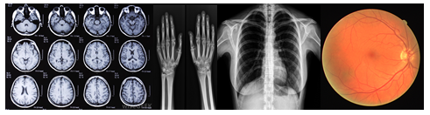**Fig 1.1 Medical Images**

In fact, medical image processing has been established as a core field of innovation in modern health care combining medical informatics, neuro-informatics and bioinformatics. Medical imaging is one of our most powerful tools for gaining insight into normal and pathological processes that affect health. It includes methods computing a new image from an initial one, computing characteristics and measurements from an image (usually named image analysis).

* 1. **OVERVIEW OF PROJECT**

Glaucoma is a second leading cause of blindness. It is a chronic ocular disease which damages the optic nerve that leads to visual impairment and blindness. About eleven to sixty-seven million people have glaucoma globally. The disease affects about two million people in the United States. It occurs more commonly among older people. Closed-angle glaucoma is more common in women. The cause of glaucoma was not known easily and hence it has been called the "silent thief of sight" because the loss of vision usually occurs slowly over a long period of time. The ophthalmoscope allowed people to see the optic nerve damage. The optic nerve carries images from the retina, which is the specialized light sensing tissue, to brain so we can see. In glaucoma, eye pressure plays an important role in damaging the delicate nerve fibers of the optic nerve.

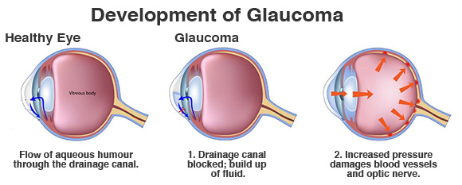

**Fig 1.2 Development Of Glaucoma**

At the 1st stage drainage canal gets blocked and buildup of fluid. This leads to the increase in IOP of blood vessels and optic nerve. Likewise glaucoma affects the eye slowly. The development of glaucoma is shown above in fig 1.2. if the entire nerve is destroyed, then blindness results. If glaucoma has been detected earlier and treated promptly then it can be controlled with no further vision loss.

Many scanning methods like HRT (Heidelberg Retinal Tomography), SLP(Scanning laser polarimetry), OCT (Optical Coherence Tomography) are used to detect glaucoma. The machines that are shown in fig 1.3 and 1.4 used for these scanning methods are so expensive cannot detect glaucoma at early stage and also requires experienced ophthalmologist to use them.

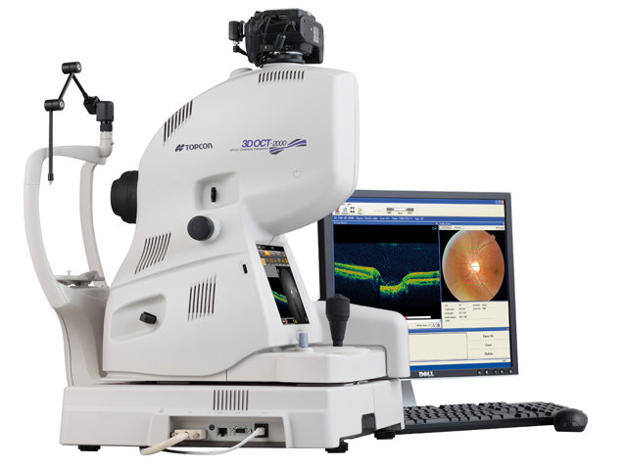 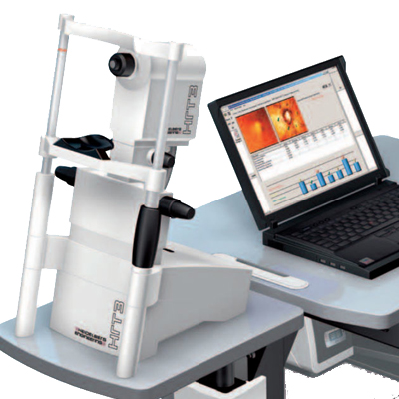

**Fig 1.3 OCT Fig 1.4 HRT**

**FUNDUS IMAGE**

The image analysed here to find glaucoma was fundus image. The fundus image was taken using the fundus camera / ophthalmoscope. The fundus of the eye is the interior surface of the retina, optic disc, macula, fovea, and posterior pole.so in order to detect glaucoma the fundus image of eye is needed. Both the normal and the abnormal fundus image will be same as shown in fig 1.5 and fig 1.6. It is very much difficult to identify the affected eye. Human examination to identify it may cause errors. It requires experiences clinicians to examine the image, even though it cannot be identified at an early stage.

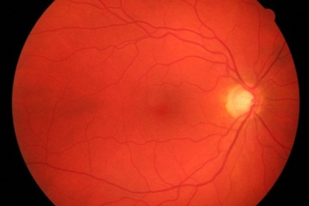 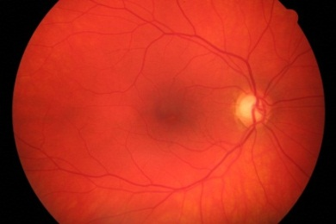

**Fig 1.5 Normal fundus Image** **Fig 1.6 Glaucoma fundus Image**

In order to avoid this, the technique called “Image processing” is used for analyzing the fundus image to detect glaucoma at an early stage. The method called “Haar Wavelet Transform” is proposed for extracting the abnormal features. In first phase, the 2-D fundus images undergo several preprocessing levels and haar wavelet transform is used for extracting the abnormal features of retina. In the second phase, the minimum spanning tree segmentation is applied using the extracted features and the segmented images undergo classification by using classifiers in order to classify normal and affected eye. Here SVM and PNN classifiers are used as classifiers. The accuracy between these two classifiers are also been compared to find the better classifier. Comparisons between classifiers are carried out to increase the classification rate. The key observation of this work is to detect glaucoma with accuracy at early stage.

* 1. **ARCHITECTURE OF IMAGE PROCESSING**

The general phases that all types of Data/Images have to undergo while using image processing technique are Pre-processing, enhancement, information extraction , segmentation, classification and display result. The general architecture of image processing was below in fig 1.3

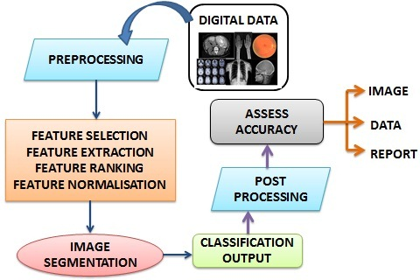

**Fig 1.7 Architecture Of Image Processing**

* 1. **SCOPE OF THE PROJECT**

Detection of glaucoma is one of the most important issues for biomedical application in image processing. Meanwhile many computer aided diagnosis are also available to identify glaucoma such as HRT (Heidelberg Retinal Tomography), SLP (Scanning Laser Polarimetry), OCT (Optical Laser Tomography), but these methods require experienced ophthalmologists to use it.

The image processing technique is an efficient way to detect glaucoma easily at an early stage. The fundus images undergo several stages such as preprocessing (image enhancement), feature extraction, image segmentation, and image classification to display result. Many image processing technique are also existing, but when compared with other technique haar wavelet transform and minimum spanning tree produce better efficiency in detection of glaucoma.

* 1. **OBJECTIVE**

The main objective of this work is to detect glaucoma accurately at early stage by developing an algorithm which automatically analyze the eye fundus images and classify whether it is a normal or glaucoma affected eye.

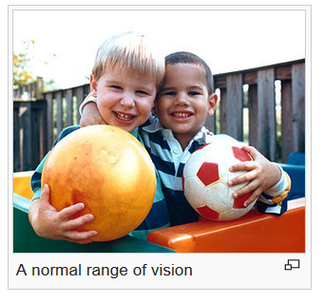 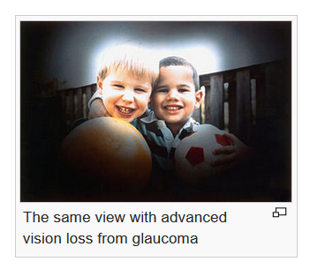

**Fig 1.8 Normal Eye Vision Fig 1.9 Glaucoma eye Vision**

If glaucoma has not been detected at early stage it affects the eye vision very badly. The difference between the normal eye vision and glaucoma eye vision has been clearly shown in fig 1.8 and fig 1.9 respectively.

**CHAPTER 2**

**LITERATURE SURVEY**

**2.1 Glaucoma Detection through Optic Disc and Cup Segmentation using K-mean Clustering.**

In 2016, Javeria Ayub, Jamil Ahmad, Jan Muhammad Lubna Aziz, Sara Ayub and Usman Akram, Imran Basit presented the Glaucoma Detection through Optic Disc and Cup Segmentation using K-mean Clustering. This paper explains One of the primary cause of blindness is Glaucoma. Although the disease is incurable but its symptoms can be minimized therefore early detection of the disease is essential. Elevated intraocular pressure, gradual vision loss which is a step towards blindness, structural damage to the retina are the marked symptoms of Glaucoma. Manually. It is diagnosed by examination of size, structure, shape of optic disc and optic cup. In patient of glaucoma Cup size increases while disc area remains the same hence cup to disc ratio (CDR) increases in glaucoma patient. CDR is the ratio of optic cup area to the optic disc area, which provides basis for the diagnosis of glaucoma. This article focuses on automated detection of glaucoma from fundus images using CDR. Region of interest (ROI) extraction through intensity weighted centroid method which is followed by preprocessing and recursively applied k-mean clustering segmentation for the detection of Optic cup (OC) and optic disc (OD). Ellipse fitting is implied for boundary smoothening of OC and OD. Performance of the proposed technique is assessed on 100 fundus images collected locally. Proposed approach gives an accuracy of 92% for glaucoma and Mean square error of 0.002 for CDR.

**2.2 Automated Diagnosis of Glaucoma Using Texture and Higher Order Spectra Features**

In 2011, U. Rajendra Acharya, Sumeet Dua, Xian Du, Vinitha Sree S, and Chua Kuang Chua presented Automated Diagnosis of Glaucoma Using Texture and Higher Order Spectra Features. This paper includes Glaucoma is the second leading cause of blindness worldwide. It is a disease in which fluid pressure in the eye increases continuously, damaging the optic nerve and causing vision loss. Computational decision support systems for the early detection of glaucoma can help prevent this complication. The retinal optic nerve fiber layer can be assessed using optical coherence tomography, scanning laser polarimetry, and Heidelberg retina tomography scanning methods. In this paper, we present a novel method for glaucoma detection using a combination of texture and higher order spectra (HOS) features from digital fundus images. Support vector machine, sequential minimal optimization, naïve Bayesian, and random-forest classifiers are used to perform supervised classification. Our results demonstrate that the texture and HOS features after z-score normalization and feature selection, and when combined with a random-forest classifier, performs better than the other classifiers and correctly identifies the glaucoma images with an accuracy of more than 91%. The impact of feature ranking and normalization is also studied to improve results. Our proposed novel features are clinically significant and can be used to detect glaucoma accurately.

**2.3 Detection of Optic Disc and Cup from Color Retinal Images for Automated Diagnosis of Glaucoma**

In 2015, Megha Lotankar, Kevin Noronha and Jayasudha Koti presented Detection of Optic Disc and Cup from Color Retinal Images for Automated Diagnosis of Glaucoma. Glaucoma is the major cause of ocular damage and vision loss in which increased Intraocular Pressure (IOP) of the eye progressively damages the optic nerve. In this proposed study, an automatic system is developed for glaucoma detection by extracting various features like vertical Cup to Disc Ratio (CDR), Horizontal to Vertical CDR (H-V CDR), Cup to Disc Area Ratio(CDAR), and Rim to Disc Area Ratio (RDAR) from digital fundus images through segmentation of Optic Disc (OD), cup and neuroretinal rim. OD is segmented using Geodesic active contour model and cup is detected using color information of the pallor region in M channel of CMY color space. The performance evaluation of the proposed technique has been carried out on 150 images comprising 75 normal and 75 glaucoma images using a set of supervised classifiers namely Naïve Bayes(NB), Support Vector Machine (SVM), and kNearest Neighbor (k-NN). On the private database, the proposed system yields the highest accuracy, Positive Predictive Value (PPV), Negative Predictive Value (NPV), specificity and sensitivity of 99.22%, 84.41%, 86.30%, 84% and 86.66% respectively using k-NN classifier. The results obtained by proposed technique indicate that this glaucoma detection system is beneficial for the clinicians in glaucoma screening programs.

**2.4 Automated Diagnosis of Glaucoma using Haralick Texture Features** In 2014, S. Simonthomas, N. Thulasi and P. Asharaf presented Automated Diagnosis of Glaucoma using Haralick Texture Features. Glaucoma is the second leading cause of blindness worldwide. It is a disease in which fluid pressure in the eye increases continuously, damaging the optic nerve and causing vision loss. Computational decision support systems for the early detection of glaucoma can help prevent this complication. The retinal optic nerve fibre layer can be assessed using optical coherence tomography, scanning laser polarimetry, and Heidelberg retina tomography scanning methods. In this paper, we present a novel method for glaucoma detection using an Haralick Texture Features from digital fundus images. K Nearest Neighbors (KNN) classifiers are used to perform supervised classification. Our results demonstrate that the Haralick Texture Features has Database and classification parts, in Database the image has been loaded and Gray Level Co-occurrence Matrix (GLCM) and thirteen haralick features are combined to extract the image features, performs better than the other classifiers and correctly identifies the glaucoma images with an accuracy of more than 98%. The impact of training and testing is also studied to improve results. The software for this algorithm has been developed in MATLAB for Feature extraction and classification. Our proposed novel features are clinically significant and can be used to detect glaucoma accurately.

**2.5 Automated Segmentation of Optic Disc and Optic Cup in Fundus Images for Glaucoma Diagnosis**

In 2012, Fengshou Yin, Jiang Liu, Damon Wing Kee Wong, Ngan Meng Tan, Carol Cheung, Mani Baskaran,Tin Aung and Tien Yin Wong. The vertical Cup-to-Disc Ratio (CDR) is an important indicator in the diagnosis of glaucoma. Automatic segmentation of the optic disc (OD) and optic cup is crucial towards a good computer-aided diagnosis (CAD) system. This paper presents a statistical model-based method for the segmentation of the optic disc and optic cup from digital color fundus images. The method combines knowledge-based Circular Hough Transform and a novel optimal channel selection for segmentation of the OD.Moreover, we extended the method to optic cup segmentation, which is a more challenging task. The system was tested on a dataset of 325 images. The average Dice coefficient for the disc and cup segmentation is 0.92 and 0.81 respectively, which improves significantly over existing methods. The proposed method has a mean absolute CDR error of 0.10, which outperforms existing methods. The results are promising and thus demonstrate a good potential for this method to be used in a mass screening CAD system.

**CHAPTER 3**

**SYSTEM ANALYSIS**

**3.1 PROBLEM DEFINITION**

The general approach for the detection of glaucoma involves in regular examination of eye by ophthalmologist. They measure the eye pressure, inspect the drainage angle of eye, evaluate optic nerve and test the visual field of each eye. These evaluations are performed at regular intervals to monitor the effect of glaucoma. For these purpose many scanning methods such as HRT, SLP, OCT are available but, these techniques undergoes human analysis which leads to chance for human error and cannot be identified at an early stage. To overcome this, the method called “fundus image analysis using haar transform” was proposed to detect glaucoma even at the early stage without any errors at high accuracy.

**3.2 EXISTING SYSTEM**

The available scanning methods such as Heidelberg Retinal Tomography (HRT), Scanning Laser Polarimetry (SLP) and Optical Coherence Tomography (OCT) are also available. Even though in Image Processing the structural features and texture features has been analyzed and extracted using various techniques like wavelet based feature, principle components, etc. classification is made on those features to identify the affected eye using classifiers such as Pnn, Knn, Ann etc.

**3.2.1 DISADVANTAGES OF EXIXTING SYSTEM**

* This analysis is not sensitive enough for detection of affected eye
* Glaucoma cannot be detected at an early stage.
* Efficiency is low.
* Execution time is high

**3.3 PROPOSED SYSTEM**

Detection of glaucoma using retinal fundus images using Haar transform and classifiers. Here the image is preprocessed to remove the noise and also to equalize the irregular illumination associated with retinal images. The abnormal features of the enhanced image are selected and extracted using Haar Wavelet transform [HWT]. The extracted image is further segmented by Minimum Spanning Tree method [MST]. Using this segmented image the classifiers such as SVM and PNN are used to classify the normal and abnormal retinal images. Experiments have been carried out to verify the ability and accuracy among these two classifiers to achieve good classification rate.

**3.3.1 ADVANTAGES OF PROPOSED SYSTEM**

* Glaucoma can be detected at early stage.
* Haar transform provide better efficiency/results for feature extraction.In terms of computation time, it produced Best performance.
* Haar Wavelet Transformations deals with Simplicity in working.
* When compared to other segmentation methods, Minimum spanning tree provides very low execution time.
* More than one classifiers have been used in order to achieve better classification rate.

**CHAPTER 4**

**SYSTEM REQUIREMENTS**

**4.1 SOFTWARE REQUIREMENTS**

Simulator :MATlab R2013a

Operating System :Windows 7

**4.2 HARDWARE REQUIREMENTS**

Processor : Intel(R)core(TM)i5-2410M CPU@2.30GHz Processor

Speed :2.30 GHz

Operating System : 64-bit operating system

RAM :4 GB RAM

**CHAPTER 5**

**SOFTWARE DESCRIPTION**

**5.1 MATLAB**

MATLAB is a [**fourth-generation programming language**](http://whatis.techtarget.com/definition/programming-language-generations) and numerical analysis environment and also a high-performance language for technical computing. It integrates computation, visualization, and programming in an easy-to-use environment where problems and solutions are expressed in familiar mathematical notation. It is used by engineers and scientists in many fields such as image and signal processing, communications, control systems for industry, [**smart grid**](http://whatis.techtarget.com/definition/smart-grid) design, robotics as well as computational finance. This is the easiest and most productive software for engineers and scientists. Whether you’re analyzing data, developing algorithms, or creating models, MATLAB provides an environment that invites exploration and discovery. It combines a high-level language with a desktop environment tuned for iterative engineering and scientific workflows.

Typical uses include:

* Math and computation
* Algorithm development
* Modeling, simulation, and prototyping
* Data analysis, exploration, and visualization
* Scientific and engineering graphics
* Application development, including graphical user interface building

MATLAB is an interactive system whose basic data element is an array that does not require dimensioning. This allows you to solve many technical computing problems, especially those with matrix and vector formulations, in a fraction of the time it would take to write a program in a scalar non interactive language such as C or Fortran.

The name MATLAB stands for *matrix laboratory*. MATLAB was originally written to provide easy access to matrix software developed by the LINPACK and EISPACK projects. Today, MATLAB uses software developed by the LAPACK and ARPACK projects, which together represent the state-of-the-art in software for matrix computation. MATLAB has evolved over a period of years with input from many users. In university environments, it is the standard instructional tool for introductory and advanced courses in mathematics, engineering, and science. Industry, MATLAB is the tool of choice for high-productivity research, development, and analysis.

### Key Features

* High-level language for scientific and engineering computing
* Desktop environment tuned for iterative exploration, design, and problem-solving
* Graphics for visualizing data and tools for creating custom plots
* Apps for curve fitting, data classification, signal analysis, control system tuning, and many other tasks
* Add-on toolboxes for a wide range of engineering and scientific applications
* Tools for building applications with custom user interfaces
* Interfaces to C/C++, Java®, .NET, Python, SQL, Hadoop, and Microsoft® Excel®
* Royalty-free deployment options for sharing MATLAB programs with end users

**Toolboxes**

MATLAB features a family of application-specific solutions called *toolboxes*. Very important to most users of MATLAB, toolboxes allow you to *learn* and *apply* specialized technology. Toolboxes are comprehensive collections of MATLAB functions (M-files) that extend the MATLAB environment to solve

particular classes of problems. Areas in which toolboxes are available include signal processing, control systems, neural networks, fuzzy logic, wavelets, simulation, and many others.

[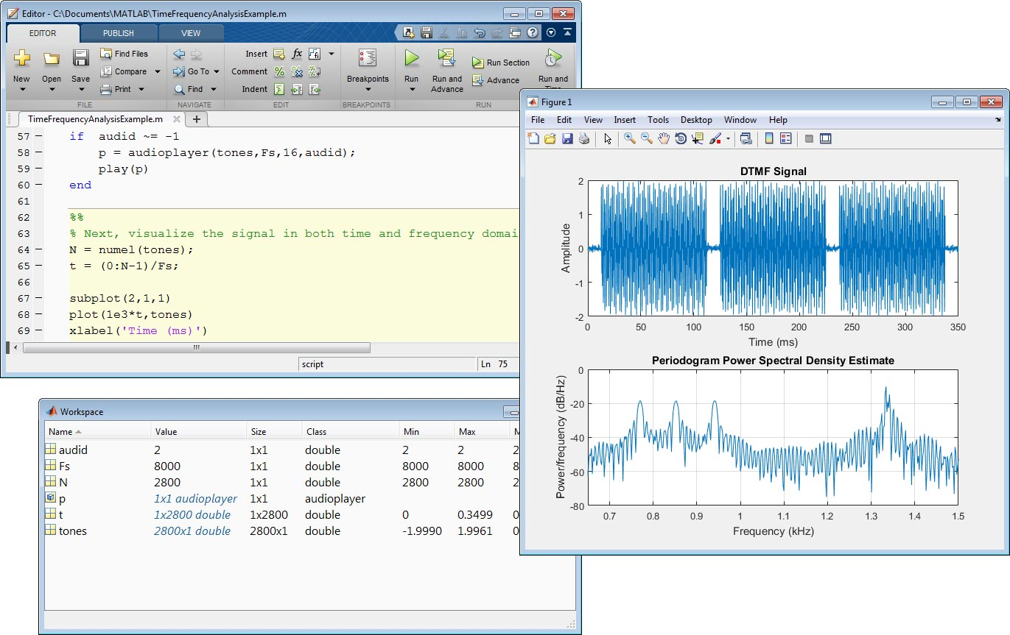](https://in.mathworks.com/cmsimages/117688_wm_MATLAB_fig1_small.jpg)

**Fig 5.1 Desktop Environment Of MATLAB**

The MATLAB system consists of five main parts:

**Development Environment**

This is the set of tools and facilities that help you use MATLAB functions and files. Many of these tools are graphical user interfaces. The desktop environment of MATLAB has shown in fig 5.1. It includes the MATLAB desktop and Command Window, a command history, and browsers for viewing help, the workspace, files, and the search path.

**The MATLAB Mathematical Function Library**

This is a vast collection of computational algorithms ranging from elementary functions like sum, sine, cosine, and complex arithmetic, to more sophisticated functions like matrix inverse, matrix eigenvalues, Bessel functions, and fast Fourier transforms.

**The MATLAB language**

This is a high-level matrix/array language with control flow statements, functions, data structures, input/output, and object-oriented programming features. It allows both “programming in the small” to rapidly create quick and dirty throw-away programs, and “programming in the large” to create complete large and complex application programs.

**Handle Graphics®**

This is the MATLAB graphics system. It includes high-level commands for two-dimensional and three-dimensional data visualization, image processing, animation, and presentation graphics. It also includes low-level commands that allow you to fully customize the appearance of graphics as well as to build complete graphical user interfaces on your MATLAB applications.

**The MATLAB Application Program Interface (API)**

This is a library that allows you to write C and Fortran programs that interact with MATLAB. It include facilities for calling routines from MATLAB (dynamic linking), calling MATLAB as a computational engine, and for reading and writing MAT-files.

## 

**CHAPTER 6**

**SYSTEM DESIGN**

**6.1 ARCHITECTURE**

A system architecture or systems architecture is the conceptual design that defines the [**structure**](http://en.wikipedia.org/wiki/Structure) and/or [**behavior**](http://en.wikipedia.org/wiki/Behavior) of a [**system**](http://en.wikipedia.org/wiki/System). An architecture description is a formal description of a system, organized in a way that supports reasoning about the structural properties of the system. It defines the building blocks of the system and provides a plan for execution of the system.

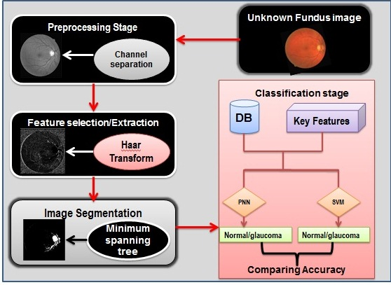

**Fig 6.1 System Architecture**

The architecture in fig 6.1 depicts that unknown fundus image is taken as the input for image analysis. The unknown retinal image undergoes several stages in order to detect glaucoma. It consists of two phases. In the first phase, the retinal images has been preprocessed and abnormal features has been extracted using haar transform. In the second phase, the extracted features are segmented for accurate results and further proceed for classification. Finally two classifiers have been used to predict the accuracy of classifiers in order to increase the classification rate.

* 1. **MODULES**
* Image Preprocessing
* Feature Selection/Extraction
* Image Segmentation
* Image Classification
* Comparing Accuracy
  + 1. **IMAGE PREPROCESSING**

The image preprocessing technique is the process of adjusting the digital images so that the results are more suitable for display (or) further image analysis. Several filter operations which intensify or reduce certain image details enable an easier or faster evaluation.

Here the unknown retinal fundus image is taken as the input for preprocessing Stage. It undergoes several levels to convert as an enhanced image suitable for further process. Here the preprocessing levels are

* Gray scale conversion
* Noise reduction
* Histogram equalization
* Resizing
* Rescaling
* Tophat filtering

The retinal image is a RGB image so in order to extract the green channel from the retina, the fundus image has been converted to gray scale image. Here noise has been removed by using the inbuilt median filters in matlab. The tophat filtering has been made in order to remove the negative region .The result of tophat filtering is shown in black and white image. All images has been rescaled and resized to 500*500. Histogram equalization is also applied to remove the irregular illumination of image.

**Gray scale conversion**

Gray scale image is one of the simplest image enhancement techniques. The process of conversion of colour image (RGB) into a gray image is called gray scale conversion. The conversion of colour image to gray scale image has shown in fig 6.2 and 6.3 respectively. It can be performed using the following function,

y=f(x) Where x: original input data; y: converted output data

A gray scale or grey scale digital image is an image in which the value of each pixel is a single sample, that is, it carries only intensity information. Images of this sort, also known as black-and-white, are composed exclusively of shades of gray, varying from black at the weakest intensity to white at the strongest.

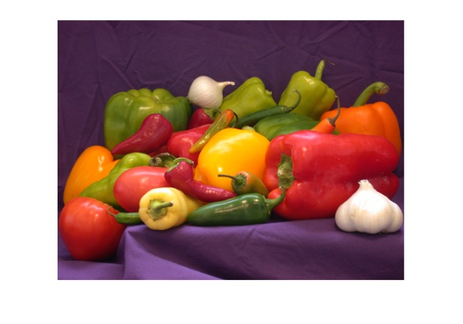 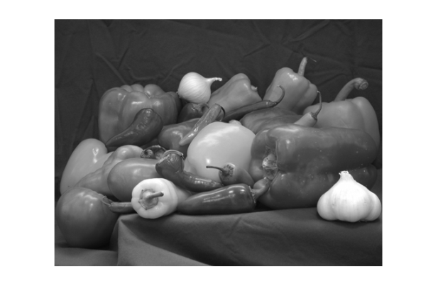

**Fig 6.2 Normal Image Fig 6.3 Gray Scale Image**

In order to extract the green channel image and noise reduction process from the RGB image, it has been converted to gray scale image. Colour digital images are made of pixels, and pixels are made of combinations of primary colours. In RGB colour model red color has more wavelength of all the three colors, and green is the color that has not only less wavelength then red color but also green is the color that gives more soothing effect to the eyes. It means that we have to decrease the contribution of red color, and increase the contribution of the green color, and put blue color contribution in between these two colours. Hence images in green bands shows fundus structures more reliably, so the green band was extracted.

**Noise reduction**

Noise reduction is the process of removing noise from a image. Images taken with both digital cameras and conventional film cameras will pick up noise from a variety of sources. Further use of these images will often require that the noise be removed. In order to get an enhanced image, noise can be added manually and removed. In salt and pepper, pixels in the image are very different in color or intensity from their surrounding pixels. The noise added image is shown in fig 6.4 and it has been removed using median filters is shown in fig 6.5. Generally this type of noise will only affect a small number of image pixels. In Gaussian noise, each pixel in the image will be changed from its original value by a small amount.

To remove noise from the image many type of filters have been used. Here mean filters have been used to remove noise. A mean filter is a non-linear filter and if properly designed, is very good at preserving image detail. Median filters and others RCRS (rank-condition rank-selection) filters are good at removing salt and pepper noise from an image. To run a median filter

* Consider each pixel in the image.
* Sort the neighboring pixels into order based upon their intensities.
* Replace the original value of the pixel with the median value from the list.

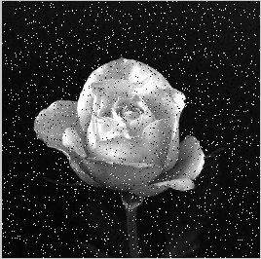 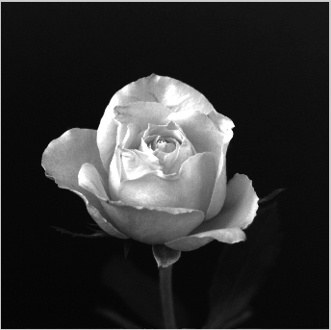

**Fig 6.4 Noise Added Image Fig 6.5 Noise Removed Image**

**Histogram equalisation**

Histogram conversion is the conversion of the histogram of the original image to another histogram. Histogram conversion can be said to be a type of gray scale conversion. There are two typical histogram conversion techniques,

* histogram equalization
* histogram normalisation

In first step, an accumulated histogram should be made. Second, the accumulated histogram should be divided into a number of equal regions. Third the corresponding gray scale in each region should be assigned to a converted gray scale. The effect of histogram equalization is that parts of the image with more frequency variation will be more enhanced, while parts of an image with less frequency will be neglected.

Image editors have provisions to create an image histogram of the image being edited. The histogram of normal image is shown in fig 6.6. The histogram plots the number of pixels in the image (vertical axis) with a particular brightness value (horizontal axis). Algorithms in the digital editor allow the user to visually adjust the brightness value of each pixel and to dynamically display the results as adjustments are made. The histogram after equalization is shown in fig 6.7. Improvements in picture brightness and contrast can thus be obtained.

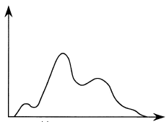 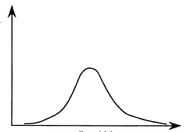

**Fig 6.6 Histogram Fig 6.7 Histogram Equalisation**

**Resizing/Rescaling**

Images taken for analysis may be different in size; analysis of such images tends to be difficult and may leads to error in results. In order to avoid this resizing and rescaling have been done in pre-processing stage. Scaling refers to the resizing of a digital image. Image resizing is necessary when you need to increase or decrease the total number of pixels, whereas remapping can occur when you are correcting for lens distortion or rotating an image.

**Top hat filtering**

Indigital image processing, top-hat filtering is an operation that extracts small elements and details from given images. Here the negative regions of the retinal image has been removed using tophat filtering technique. Tophat filtering enhances the bright object in a dark background. For example: galaxy, it consists of small bright particles in dark background as shown in fig 6.8. These bright particles can be removed separately from the dark background of galaxy by using top hat filtering method. This has been clearly shown in fig 6.9. There exist two types of top-hat filtering,

|  |  |  |
| --- | --- | --- |
| * White top-hat filtering | **-** | The difference between the input image and  its opening by some structuring element. |
| * Black top-hat filtering | **-** | The difference between the closing and the  input image. |

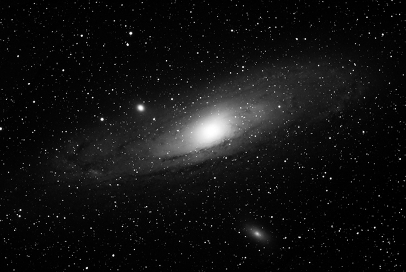 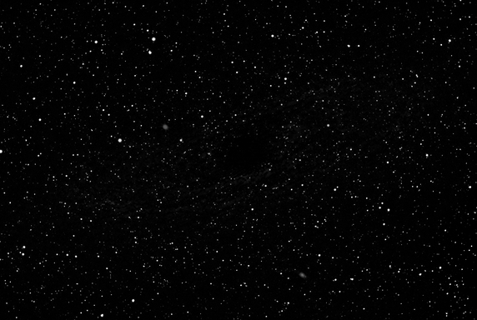 **Fig 6.8 Normal Image Fig 6.9 Tophat Filtered Image**

**6.2.2 FEATURE SELECTION/EXTRACTION**

A feature is nothing but the significant representative of an image which can be used for further segmentation and classification .Feature selection is the first step to get the feature extracted images. This method is very much helpful to the repeated feature and the selected feature which has no data. It will not choose without data, will not useful for future processing.

The selected feature has been extracted to simplifying the amount of resources requires to describe a large set of data accurately. Feature Extraction is a general term which depicts to extract only valuable information from given raw data. The main objective is represent raw image in its reduced form and also to reduce the original data set by measuring certain properties to make decision process easier for classification

The proposed method called “Haar Wavelet Transform” is used for feature extraction. Nowadays the wavelet theorems make up very popular methods of image processing. Due to its low computing requirements, The Haar transform has been mainly used for image processing and pattern recognition. It has efficient application due to their wavelet like structure.

To improve the accuracy, the efficient algorithm called “haar wavelet transform” is used for feature extraction. This method is applicable for different kinds of image extraction features.



**Fig 6.10 Haar Transformation**

Haar Wavelet transform is used to calculate the feature vectors of textured images. Here it converts texture of retinal image to comparable mathematical characterization. The image is decomposed to approximate components and detail components by 2-D wavelet function. The decomposition process by 2-D wavelet transform from the high scale to the low scale indicates approximate components.the decomposition of HWT is shown in fig 6.10, as *HH, HL, LH* (corresponding to , and ) indicates detail components.

The general form of decomposition haar transform is shown in fig 6.11 as follows,

|  |  |
| --- | --- |
| A | H |
| V | D |

**Fig 6.11 General Form Of Haar Transform**

A- (Approximation area) includes information about the global properties of analysed image. Removal of spectral coefficients from this area leads to the biggest distortion in original image.

H- (Horizontal area) includes information about the vertical lines hidden in image. Removal of spectral coefficients from this area excludes horizontal details from original image.

V- (Vertical area) contains information about the horizontal lines hidden in

Image. Removal of spectral coefficients from this area eliminates vertical details from original image.

D- (Diagonal area) embraces information about the diagonal details hidden in image. Removal of spectral coefficients from this area leads to minimum distortions in original image.

Finally haar transform is composed of four coefficients such as A,H,V,D as shown above .Thus the H,V,D coefficients are compared with the approximation coefficients value. Here the approximately assigned value is 0.003.so the feature that are more different from the approximate features are get extracted for further process.

* + 1. **IMAGE SEGMENTATION**

Image segmentation is the process of partitioning a digital image into multiple segments (sets of pixels, also known as super-pixels). The goal of segmentation is to simplify and/or change the representation of an image into something that is more meaningful and easier to analyze. Image segmentation is typically used to locate objects and boundaries (lines, curves, etc.) in images. More precisely, image segmentation is the process of assigning a label to every pixel in an image such that pixels with the same label share certain characteristics.

The result of image segmentation is a set of segments that collectively cover the entire image, or a set of contours extracted from the image (see edge detection). Each of the pixels in a region is similar with respect to some characteristic or computed property, such as color, intensity, or texture. Adjacent regions are significantly different with respect to the same characteristic(s). When applied to a stack of images, typical in medical imaging, the resulting contours after image segmentation can be used to create 3D reconstructions with the help of interpolation algorithms like marching cubes.

The several approaches of image segmentation are

* Edge-based segmentation
* Region growing
* Region split and merge
* Watershed segmentation
* Segmentation by motion

Image segmentation is an important and challenging problem in image analysis in the field of machine vision for a unsupervised object based segmentation. Minimum spanning tree method is used as a proposed work for image segmentation.

MST is a undirected graph which contains all edges and vertex of the graph. It is also called shortest spanning tree which is the important concept of graph theory. Here MST algorithm is used for medical image segmentation. MST is a sub graph that compasses over all the vertices of a given diagram with no cycle and has least entirely of weight over all the induced edges. In MST based clustering ,the weight of every edge is considered as the Euclidean separation between the end focus framing the edge .Accordingly any edges that in faces two sub trees in the MST must be the briefest. In such grouping, routines, conflicting edges which are surprisingly more are expelled from MST.

Basically MST has two types spanning tree algorithm. they are

* Prim’s algorithm
* Kruskal’s algorithm

Here kruskal’s algorithm based minimum spanning tree is used for segmentation. First all small clusters are generated. In this method, which edges have minimum weight are connected and finally make a large cluster. After making this cluster edge inconsistency is applied to remove largest edge. 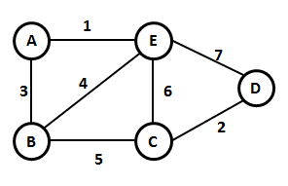 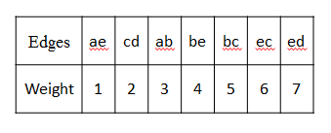

**Fig 6.12 Weighted Graph**

By applying Kruskal’s algorithm,

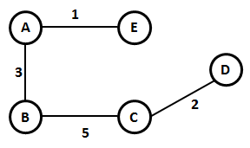

**Fig 6.13 After Applying Kruskal’s Algorithm**

**6.2.4 IMAGE CLASSIFICATION**

Classification refers to the analysis of the properties of an image depending upon the analysis. It is one of the most often used methods of information extraction they classifies the extracted features to identify the normal and abnormal images. These are done using classifiers. Usually multiple features are used for a set of pixels i.e., many images of a particular object are needed. Most of the information extraction techniques rely on analysis of the spectral reflectance properties of such imagery and employ special algorithms designed to perform various types of 'spectral analysis'. The process of multispectral classification can be performed using either of the two methods:

* Supervised classification
* Unsupervised classification

Experiments have been carried out to find the better classifiers. Here the classifiers used are,

* SVM
* PNN

PNN (probabilistic neural network) is a kind of supervised neural network that is widely used for pattern recognition.

SVM (support vector machines) are supervised learning models with associated learning algorithms that analyze data used for classification and regression analysis.

* + 1. **COMPARING THE ACCURACY**

In order to predict the better classifier and to increase the classification rate two classifiers called SVM and PNN classifiers have been used to detect the normal and abnormal retinal image.

**CHAPTER 7**

**CONCLUSION**

A method called “haar wavelet transform” has been proposed for feature extraction in analyzing the fundus image. It is capable for extracting the abnormal features vertically, horizontally, diagonally of the given image accurately. It is used to reduce the overall time complexity. This effectively minimizes the undesirable results and gives a good matching pattern, that will behaving zero or a minimum set of no relevant images. Hence this work was successfully identifies the affected features of the retinal image by using this proposed system.

**APPENDIX-1**

**SAMPLE CODINGS**

%%%%%%%%%preprocessing %%%%%%%%%

clc;clear;

close all;

[Path,U_C]=imgetfile;

IMA=imread(Path);

IMA = imresize(IMA,[500 500]);

figure('name','Test Image','numbertitle','off');

imshow(IMA);impixelinfo;

Igreeno=(IMA(:,:,2));

Igreen=(IMA(:,:,2));

figure('name','Green Channel Image','numbertitle','off');

imshow(Igreen);

impixelinfo;

Igreen = histeq(Igreen);

figure('name','histogram equalization','numbertitle','off');imshow(Igreen);impixelinfo;

Igreen = imresize(Igreen,[500 500]);

figure('name','resizing','numbertitle','off');imshow(Igreen);impixelinfo;

Igreen = im2double(Igreen);

figure('name','rescaling','numbertitle','off');imshow(Igreen);impixelinfo;

In = 1-(Igreen);

Idark = abs(In-Igreen);

figure('name','Image with negative regions','numbertitle','off');imshow(In);impixelinfo;

SE = strel('line', 9,15);

Idark = imadjust(imtophat(Idark,SE));

figure('name','Image with dark regions','numbertitle','off');imshow(Idark);impixelinfo;

figure('name','Image with dark regions imbw','numbertitle','off');imshow((im2bw(Idark)));impixelinfo;

%%%%%%%%%%%Haar wavelet Transform%%%%%%%%%%%%

[ll lh hl hh] = dwt2(Igreen,'haar');

dwt_out = [ll lh ; hl hh];

figure;

imshow(ll,[]);

impixelinfo;

title('Approximation Coefficients Image');

figure;

imshow(lh,[]);

impixelinfo;

title('Details Coefficients Image1');

figure;

imshow(hl,[]);

impixelinfo;

title('Details Coefficients Image2');

figure;

imshow(hh,[]);

impixelinfo;

title('Details Coefficients Image');

%%%%%%%%%%%%%%%%%%%%%%%%%%%%%%%%%%%%%%%%

**APPENDIX-2**

**SCREEN SHOT**

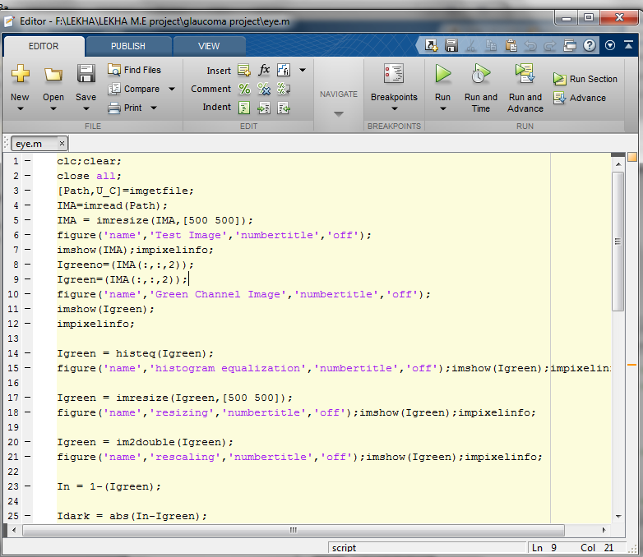

**Fig 8.1 Workspace Of MATLAB**

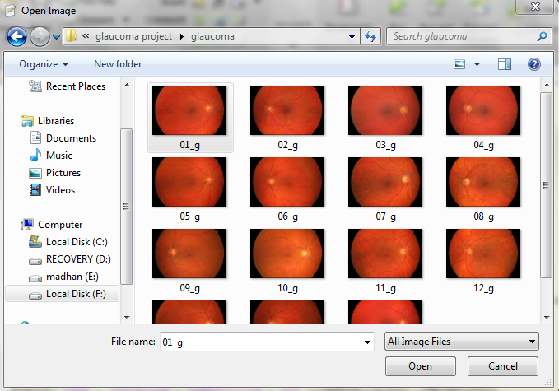

**Fig 8.2 Input Image For Analysis**

**Fig 8.3 Test Image**

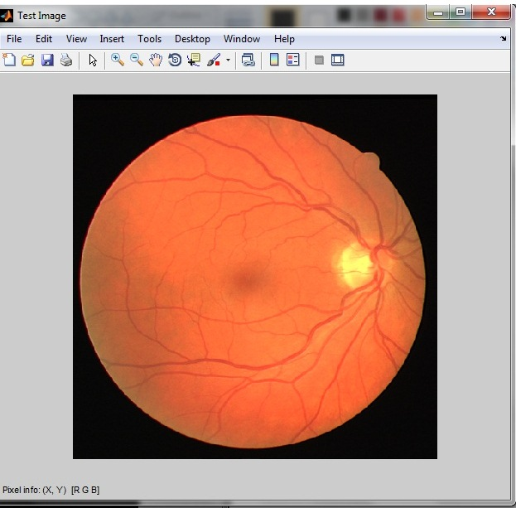

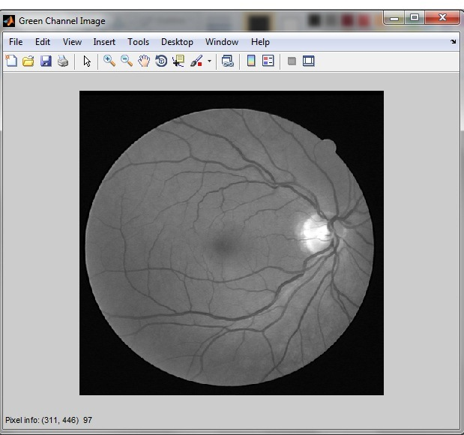

**Fig 8.4 Green Channel Image**

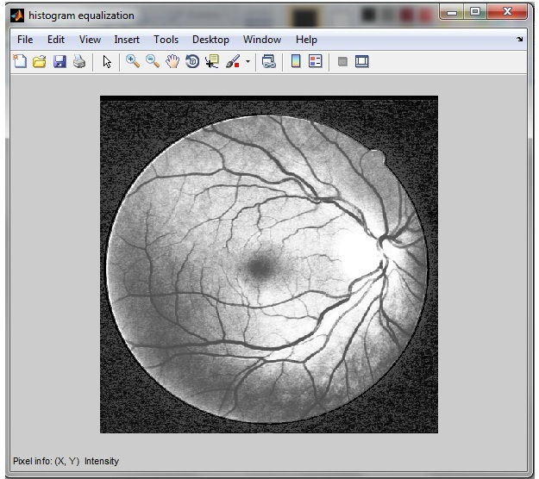

**Fig 8.5 Histogram Equalisation**

**Fig 8.6 Resizing**

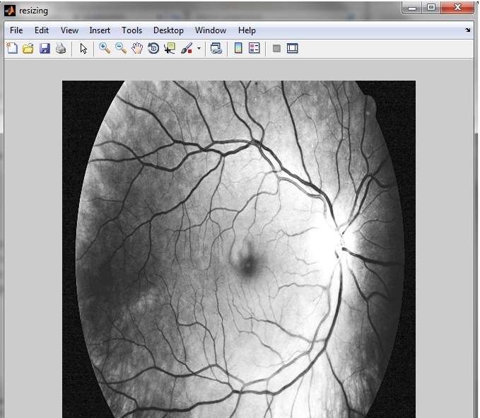

**Fig 8.7 Rescaling**

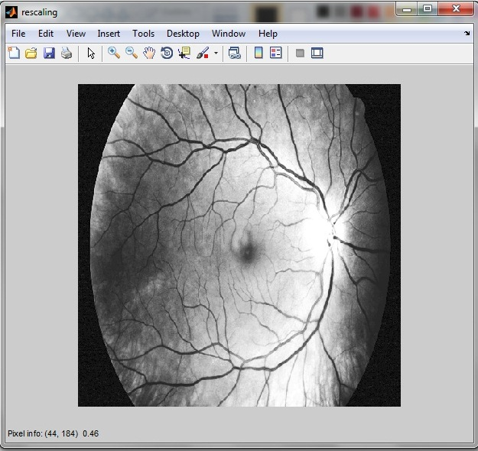

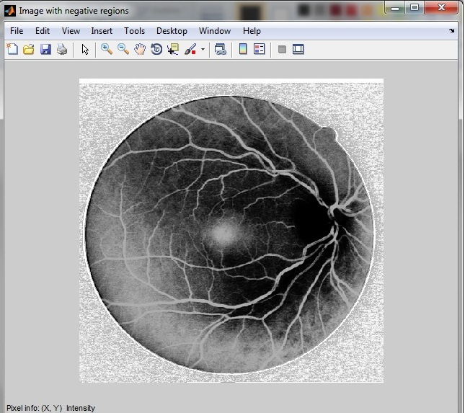

**Fig 8.8 Image With Negative Region**

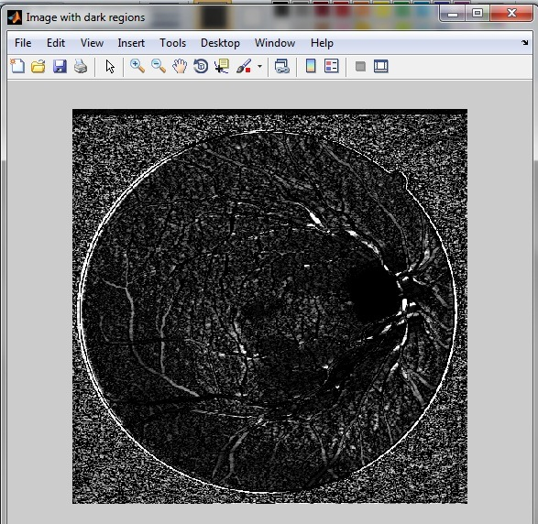

**Fig 8.9 Image With Dark Region**

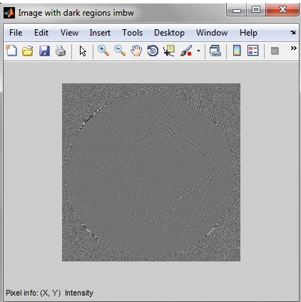

**Fig 8.10 Image With Dark Region Imbw**

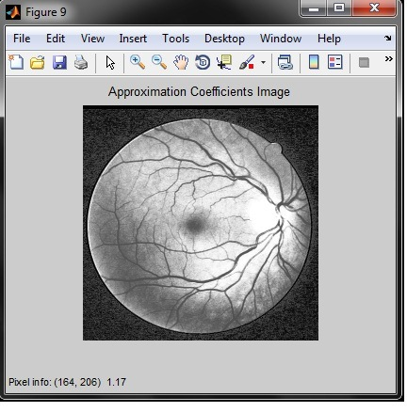

**REFERENCES**

1. B. Dashtbozorg, A. M. Mendonça, and A. Campilho,(2014)``Optic disc segmentation using the sliding band filter,'' *Comput. Biol. Med.*, vol. 61, pp. 2112_2124.
2. H. Fu, D. Xu, S. Lin, D. W. K. Wong, and J. Liu,(2015) ``Automatic optic disc detection in OCT slices via low-rank reconstruction,'' *IEEE Trans.* *Biomed. Eng.*, vol. 62, no. 4, pp. 1151_1158.
3. J. Cheng *et al.*,(2013) ``Superpixel classi_cation based optic disc and optic cup segmentation for glaucoma screening,'' *IEEE Trans. Med. Imag.*, vol. 32,no. 6, pp. 1019_1032,
4. J. Nayak, U. R. Acharya, P. S. Bhat, N. Shetty, And T. C. Lim,(2009) “Automated Diagnosis Of Glaucoma Using Digital Fundus Images,” IEEE Journal Of Medical Systems, vol. 33, No. 5, pp. 337–346.
5. M. C. V. S. Mary, E. B. Rajsingh, J. K. K. Jacob, D. Anandhi, U. Amato, and S. E. Selvan,(2014) ``An empirical study on optic disc segmentation using an active contour model,'' IEEE *Biomed. Signal Process. Control*, vol. 18, pp. 19_29.
6. M.Zavar, S.Rahati, M. R.Akbarzadeh-T, And H.Ghasemifard,(2011) “Evolutionary Model Selection In A Wavelet-Based Support Vector Machine For Automated Seizure Detection,” Expert Systems With Applications, vol. 38, No. 9, pp. 10 751–10 758.
7. S. Dua, U. R. Acharya, P. Chowriappa, And S. V. Sree,(2012) “Wavelet Based Energy Features For Glaucomatous Image Classification,” IEEE Transactions On Information Technology In Biomedicine,vol. 16,No.1 pp. 80–87.
8. S.Youse_ *et al.*,(2014) ``Glaucoma progression detection using structural retinal nerve _ber layer measurements and functional visual _eld points,'' *IEEE Trans. Med. Imag.*, vol. 61, no. 4, pp. 1143_1154.
9. Swamidoss Issac Niwas, Weisi Lin, Chee Keong Kwoh, C.-C. Jay Kuo,Chelvin C. Sng, Maria Cecilia Aquino, And Paul T. K. Chew (2016) “Cross-Examination For Angle-Closure Glaucoma Feature Detection” IEEE Journal Of Biomedical And Health Informatics, Vol. 20, No. 1